Introduction to Langchain - Is the Open source Framework which helps to build a Intelligent AI Application along with LLM models, Database, Documents, APIs, Memory, Agents

Explain me about Langchain Ecosystem: LangChain Ecosystem என்பது LangChain Framework மட்டுமல்ல; AI Application உருவாக்க தேவையான அனைத்து Components, Tools, Libraries மற்றும் Platforms-களின் தொகுப்பு ஆகும்.

1.LangChain Core: இதுதான் முக்கிய Framework.
இதன் வேலை:
- LLM Integration
- Prompt Management
- Chains
- Memory
- Tools
- Agents

2.LangGraph: LangChain-ன் Next Generation Framework to generate Complex AI Workflows.
ஒவ்வொரு Agent-உம் தனி பொறுப்பு.

3.LangSmith: AI Application Monitoring Tool, Tracing Logs, AI Application எப்படி வேலை செய்கிறது என்பதை Track செய்ய.
Monitor செய்யக்கூடியவை
- Prompt
- Response
- Latency
- Token Usage
- Errors
- Chains
- Agents

4. LangServe: LangChain Application-ஐ API ஆக Publish செய்ய பயன்படும்.
5. LangChain Components:
6. Data Ingestion: Data Ingestion is the process of collecting data from various sources, loading it into an AI system, cleaning and chunking the content, generating embeddings, and storing them in a vector database so that LLMs can retrieve relevant information and provide context-aware responses. It is the foundation of RAG-based AI applications.

-- Use Document Loader to load any type of file (text, pdf, docx, etc..) ---- pip insall pypdf
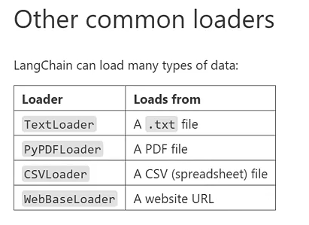

Text_Splitter = “””A Text splitter breaks a large text into smaller pieces called chunks.”””
Chuck_size (100%)
Chunck_overlap (40%)

Always use 60-40 ratio.

To find the length: print(“Total Characters:”, len(Text_Splitter))

To Split the text: Use “RecursiveCharacterTextSplitter”

To Split the Documents: Use “split_documents()”

Embeddings: Embeddings turns text into numbers ( a list of numbers called a Vector).

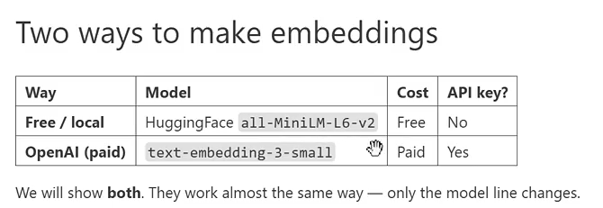

How to install free local model from Huggingface,

--pip install langchain-huggingface sentence-transformers
--pip install langchain-openai

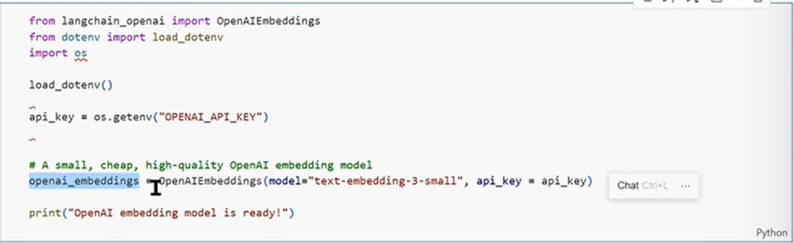

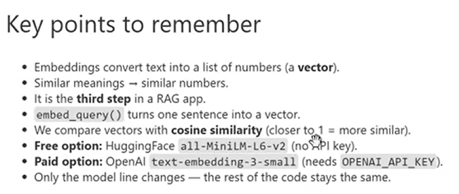

Vector Store:

A special database that saves embeddings. It let us search by meaning very quickly.

4th step in RAG.

--Pip install faiss-cpu

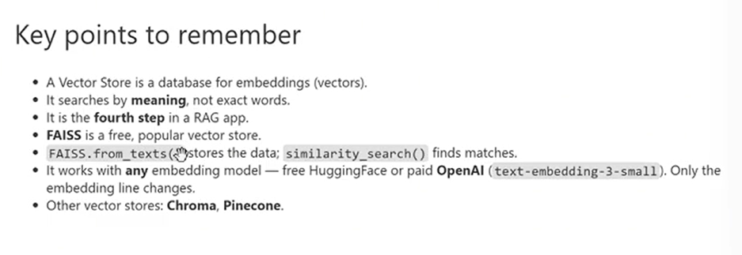
Retriever: A Retriever is the tool that fetches the most relevant text from the vector store when you ask a question. It is the final step that connects your data to an AI model.

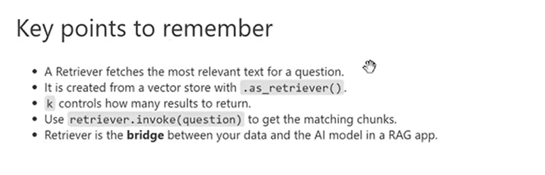
Chains:
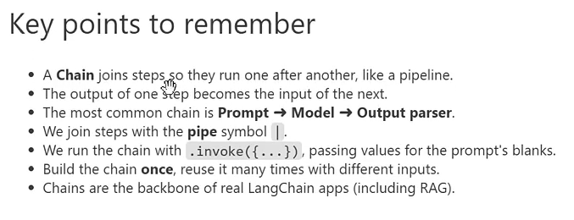
Langsmith: It’s a website that records and shows everything your AI apps does.

--Pip install langsmith

